**FreshPoint Opco 129:**

This Opco uses Roadnet Anywhere which we don’t support. In case of any Roadnet issue related to this OPCo then we don’t support them.

**Unassigned Route Issue:**

Freshly imported routes will be in unassigned state. Once router starts assigning it ll be moved

to Active state.

Properly completed routes will be in Built state. Completed Route details will be sent to SUS

using 'send orders'.

Router has not added the order to a route properly or not worked on, it will be in unassigned state.

supermatrix- takes care of determining the optimized route.

**User application view/settings messed up:**

transfer the .wps and .cps files from backup and move it to current user folder.

1.            Check with user for which module we need to restore

2.            If it’s routing module please copy the below files

a.            rnedrte.cps (column positioning)

b.            rnedrte.wps (windows positioning)

3.            For maintenance module copy the below files

a.            tsmaint.cps (column positioning)

b.            tsmaint.wps (windows positioning)

**Adding new user In RI:**

1.Send mail to account admin to add user under distribution lists based on

USBL/FP/Meat/Canada/Mexico/Bahamas/Alaska/Ireland. Once assigned back to roadnet proceed to below step.

2.User details has to be added in UserConfig in all the citrix servers.

Kareem has the app to add user details in all servers.

Only USBL routers use roadnet interface. Others only use Roadnet application.

20000/25000 end users.

300-350 routers

1.2 to 2.2 million miles driven by drivers daily and it goes through Roadnet.140 warehouses/locations.

**unable to download orders to Roadnet - End of Job error (Special Instruction Issue):**

Issue:

1. Adding special instructions by router more than a limit causes delivery date changes to be missing in SUS.

Reason is SUS not able to read that customer info as the columns are shifted in customer.s file.

2. SUS throws error back to Roadnet Interface when the special instructions are more than a specific limit.

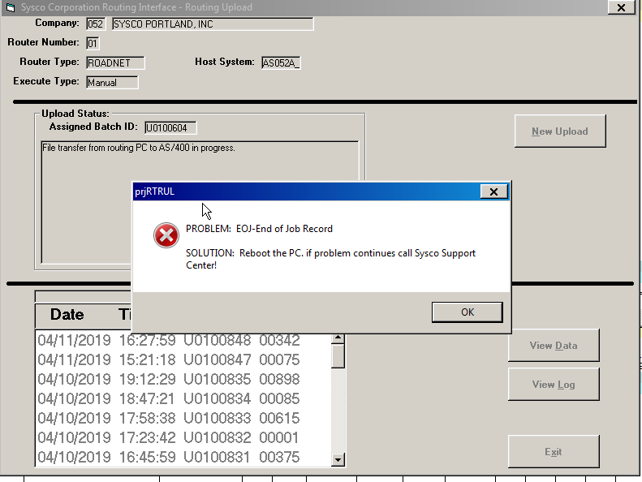

Ask the user to remove extra instructions and submit the delivery date changes again.

Orders will be uploaded after modifying the special instructions or ask the user to remove that particular order and then submit the others.

**Equipment/Employee to be added in Gasboy.**

Gasboy system maintains the equipment’s (trailers/tractors) and also gas usage of the trailers/tractors. It maintains the driver details as well.

Retrieve the details from Sprocket Db using 'equipment id'/’employee id’ and Import the file in Gasboy.

**User is not able to export/send/upload the built routes to SUS: (License exceeded)**

There are 2 options:

Verify the limit in Roadnet.

1.Check with the router whether he can split and upload the routes to have it with in the limit.

2.Increasing the routing limit in Roadnet.

Admin module, regions, links tab. Copy Roy to proceed further with it.

**Telogis:**

Verizon connect - application that shows live driver details and the stops.

**Error message while logging to Roadnet application:**

Username to access Roadnet Interface is case sensitive. If user typed wrongly or user is not setup in USERCONFIG file, then this error will be thrown.

Once you checked with user and provided resolution update ticket priority to Medium/low.

Change the status to Resolved, provide resolution comment.

**Unable to login to Roadnet:**

When user tries a wrong password 3 or more times login will be locked. Contact SUS OP team (Jordan Steph) to clear the lock.

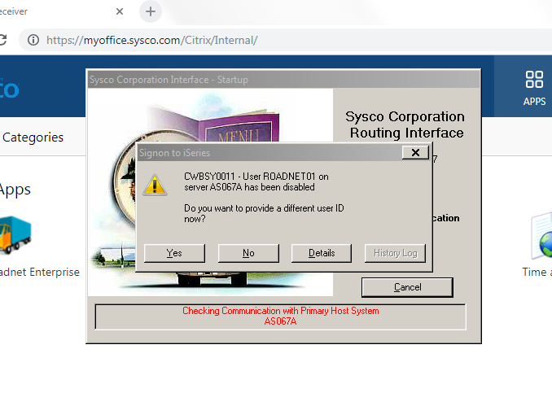

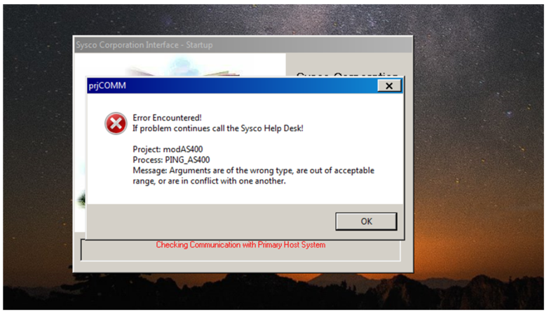

Server 7 has some problems. I got the same error when I tried and once it picked up server 16 eveything worked fine.

**User login defaulted with password in RI interface issue: (mrrobot8) shown in place of username:**

The user details have to be deleted from citrix server by contacting citrix server team.

08/11/13 citrix servers have local profile - so delete the user profile and user can login again.

other servers roaming profile so user profile has to be reset by that team.

**Roadnet - Unable to log into Roadnet as roadnet01, only roadnet04**

**Roadnet Locked session**

1.Check the userconfig (\\ms212rdctx<servernumber>\routing) file first

2. Check config (\\ms212rdctx<servername>\routing\320-1) files to see whether it has the router number in the end of the first line. If not try to replace the config file in all servers using <http://10.242.140.84:3001/> Replace RI Config option.

If both does not work, then contact citrix team to reset user profile.

**Not able to print files:**

1.While trying to print a file in Roadnet, it will ask for permission and if user did not give all access or read and write, then file will not get printed and error "not able to open file" will be thrown. Also, sometimes .xls file will not open and only .xlsx is allowed.

2.Either the printer is not configured and it should be done by citrix team.

**user is trying to print from Roadnet. It won't select server to print. On Server 14 he's able printer. He needs setting replicated to be able to print:**

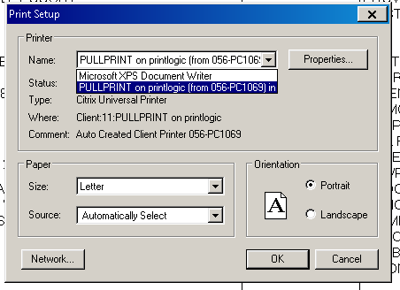

Assign it to citrix team.

**Delivery day Upload:**

Update the dates, save and then upload it to SUS/AS400.

Delivery dates that have changed after last run will be picked up and sent to SUS if someone submits

the changes to SUS using.

**Cubitron:** Not sure anything about this application. Check with Jose about this application and

get details.

**Received a new computer and now cannot login to Roadnet:**

He can login but the programs will not open. He can login to Roadnet interface and routing but when he clicks on routing it will not open.

User was able to login but when he clicks the options it was not opening.

**Resolution:**

1.Check the Display settings and set the resolution to recommended percentage.

2. Go to citrix receiver connection center->advanced preferences->High DPI->choose option ‘Yes’.

**Roadnet getting access denied messages:**

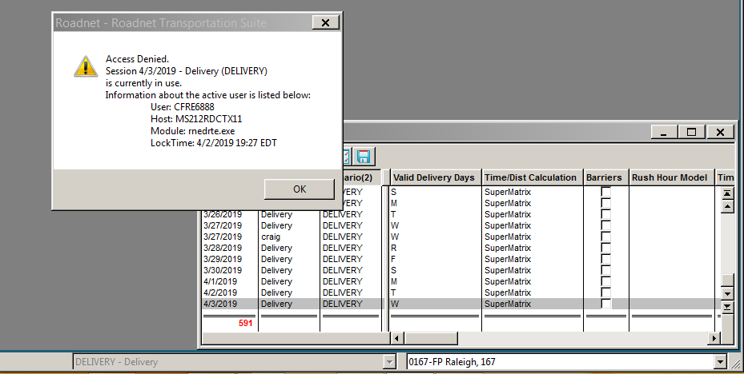

Contact the user and ask for a screen shot. Check whether the issue is in Roadnet application. This issue comes due to DB session lockout.

Ask the user the log off from connection center and log back. If user says it takes long time, then do a screen share and see whether the session is time out. If yes, ask user to refresh the browser (F5) and then log back in.

**unable to download orders to Roadnet - End of Job error**

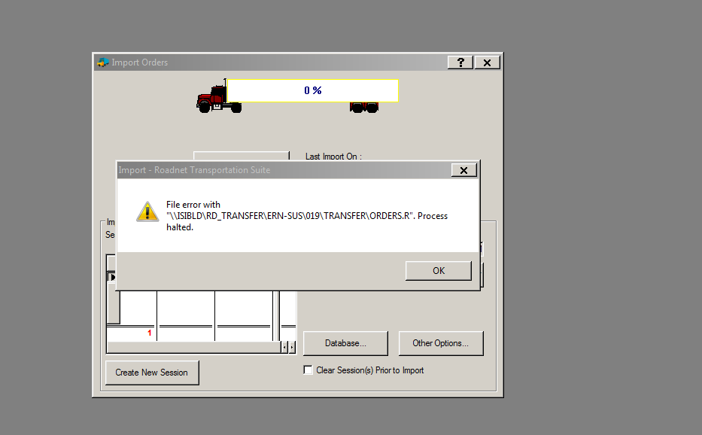

Router should not be in the same session in routing module into which he is trying to import into. Routing module can be open, but the session should not have been selected. Reason being DB has a lock has a lock when router selects a session, so orders cannot be imported into same session.

**Routes not flowing from Roadnet to SWMS at 023 opco:**

Problem Description: Has 7 routes that never came through Roadnet to SWMS. Holding up the warehouse because those are the next routes that he needs to select to get out of there on time. Business impact is High due to they are holding up the warehouse. Please address with critical priority. Route numbers 5551, 5555, 5564, 5565, 5581, 5583, and 5591. Routes all came through except for these 7. If it is not fixed in the next 20 minutes it will result in trucks being late and there are about 30 routes behind that, resulting in about 35 late trucks.

Route numbers will be there only after it had been successfully downloaded and router has worked on it. If route number is mentioned in the issue, it means router has worked on it already. Hence, check whether it had been uploaded or not.

**Resolution Steps:**

1.Check the routing folder in that opcode on each server **\\ms212rdctx06\routing\023-1\RTRUL****.**

2. Check whether there is an upload batch file present around the time of issue. Open the file and check for the routes mentioned in issue.

* If routes are present, then it means routes have been sent successfully to SUS. Involve SUS and SWMS team to check why the order has not reached warehouse.
* If routes are not present it means user has not uploaded the routes and engage the user to upload the routes from Roadnet.

**Get these details from Kareem:**

1.Hot Shots/Same day Delivery orders:

Usually routing scheduled today will be for delivery of orders tomorrow.Some cases the order will be

scheduled on the day of delivery (morning) itself. How to identify these orders.

These orders will be added in order download file even if PP07 has not run.Reason being the

orders are marked as immediate.

2.Email Id that updates details in remedy while having mail conversation with customer. Incoming-BMC

UDP/telnet to see whether a server is accessible.

Eg:telnet 10.200.131.11

3.How to access DB's for getting Roadnet customer and order details?

User name and password details for DB.

1.Roadnet DB details.

2.Sprocket DB Details.

3.Roadnet Interface DB (SRI)

4.Non SUS roadnet shared inbound/Outbound folder path (FP/Meat/Canada/Mexico/Bahamas/Alaska/Ireland/Europe).

5.Setup AWS SRI environment. Code and setup issues like webservice end point set up,etc..

6.Does Roadnet Interface have any DB? Yes, we have access to it. In SRI,

user details are from Active directory. So same sysco id can be used to access Roadnet.

When account admin team adds user to DL list, user will gain access to Roadnet application as well.

7.Data from Prod Roadnet DB will be backed up 2AM every day to data warehouse DB. If some order is

missing in prod i.e user deleted mistakenly then it can be retrieved from data warehouse DB

and manually loaded in roadnet application.

We have access to Roadnet Datawarehouse DB but not to Prod.

SRI testing:

AS242K test system for SUS/AS400.PP07 job in SUS brings the order down to Roadnet interface.

So when we download from SUS, PP07 job brings all the orders from SUS irrespective of

delivery date.

In Production:

When we download order using Roadnet interface from SUS today, orders that has been created

yesterday with the delivery date as today will be downloaded.

Order files will be downloaded to RTRDL folder with a unique batch id by a batch when order download

option is opened.

When router clicks new download the those records will be copied to Orders.R and imported into

Roadnet when router clicks Import in roadnet app.

Session creation is done in SRI to group the orders and send it to Roadnet

for routing.

**File not uploaded from Roadnet to SUS/SWMS:**

Order information was uploaded by router but was not shown in SUS and SWMS. Check the particular

server folder path RTRUL to see whether there is a file that is present for that particular date

and time issue was raised. If it is there, then RI has uploaded the file successfully but SUS has not

picked it up.

**Resolution:**

Setup a bridge call with team that manages PP07 job, SUS and SWMS team. PP07 team and SUS had some

issue in their system and they fixed their system and file went through.

OPRN20LE - Executed by the routing PC after records have been successfully transferred from the

routing PC to the AS/400. The program updated OPRSRPTF with data such as Route, Stop numbers, etc

.It also validates that the orders have not been previously routed. If the order is valid for

processing, the program marks the OPRSRPTF records as being routed, to prevent the order from

being downloaded or uploaded again.

OPRN22LB - Retrieve the entry panel record for the batch its processing.

In the entry panel records is the batch id that need to be processed.

The program then copies data with the same batch id from OPRSRPTF to ULRNWRPF in library QTEMP.

**Telogis Contact Details:**

Issue : Need functional account set up for Telogis laptop   
  
For Telogis access related request, please reach out to "Verizon connect". Following is their contact detail.   
  
Email: Verizon Connect Support [support@srv.verizonconnect.com](mailto:support@srv.verizonconnect.com) OR [syscosupport@telogis.com](mailto:syscosupport@telogis.com)

Support Center Number 24x7:

866.884.8538

Please let us know if any further assistance is required from our end, We will be glad to help you.

Please reach Verizon Connect/Telogis team for Telogis access related and let us know if any further assistance is required from our end, We will be glad to help you.

or TELOGIS Sign, please reach out to “Verizon Connect Support”. Following is their contact detail.

Email:

[support@srv.verizonconnect.com](mailto:support@srv.verizonconnect.com) OR [syscosupport@telogis.com](mailto:syscosupport@telogis.com)

Support Center Number 24x7:

866.884.8538

Gasboy:

INC000000096814 - Assigning it to TECH400 team to reset the password for SUS -ID CUBITRON as this is the user-id used for uplaoding from Cubitron to SUS.

